# CT03: Concept Test

**Part 1 (Due Wednesday)**

Which statement will not return a valid result set?  Justify your answer

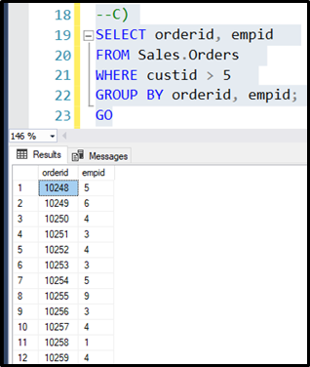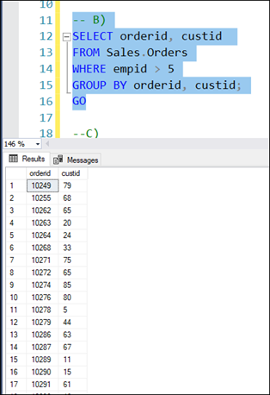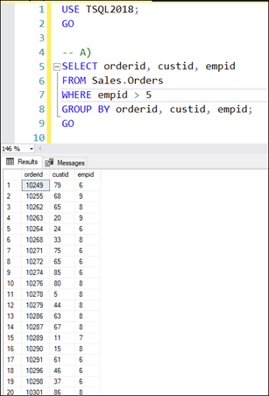

a)   SELECT orderid, custid, empid

FROM Sales.Orders

WHERE empid > 5

GROUP BY orderid, custid, empid;

b)   SELECT orderid, custid

FROM Sales.Orders

WHERE empid > 5

GROUP BY orderid, custid;

c)   SELECT orderid, empid

FROM Sales.Orders

WHERE custid > 5

GROUP BY orderid, empid;

d) SELECT orderid, custid, empid

FROM Sales.Orders

WHERE empid > 5

GROUP BY orderid, custid;

